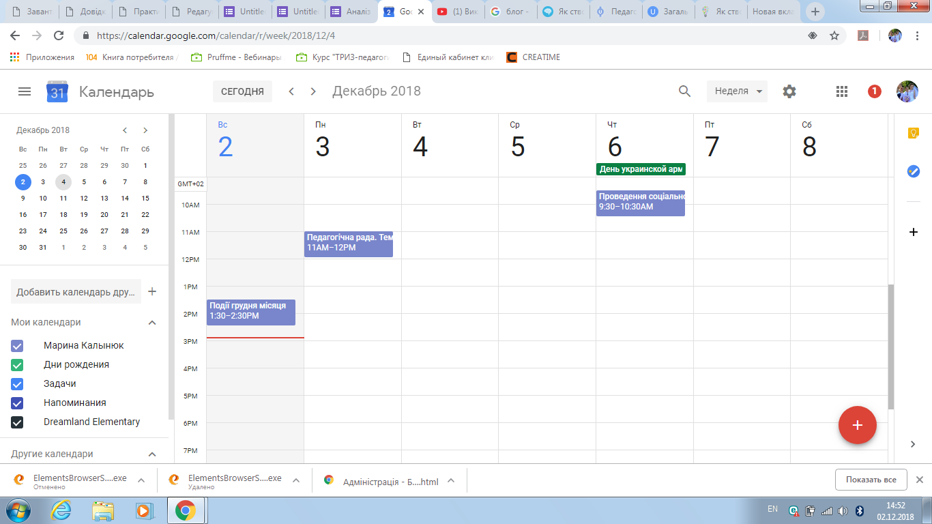

https://calendar.google.com/calendar/r/week/2018/12/4

