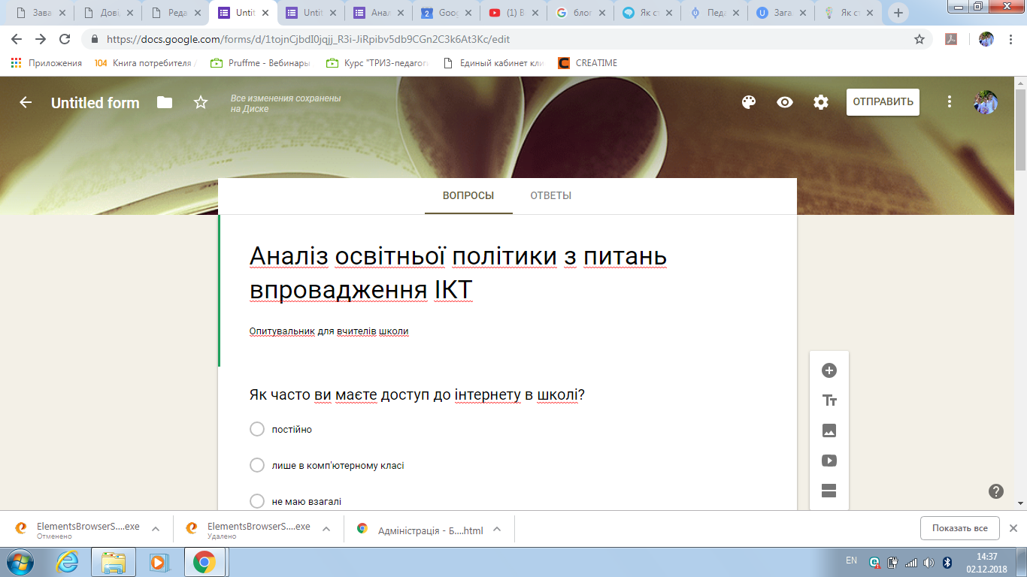

https://docs.google.com/forms/d/1tojnCjbdI0jqjj_R3i-JiRpibv5db9CGn2C3k6At3Kc/edit

